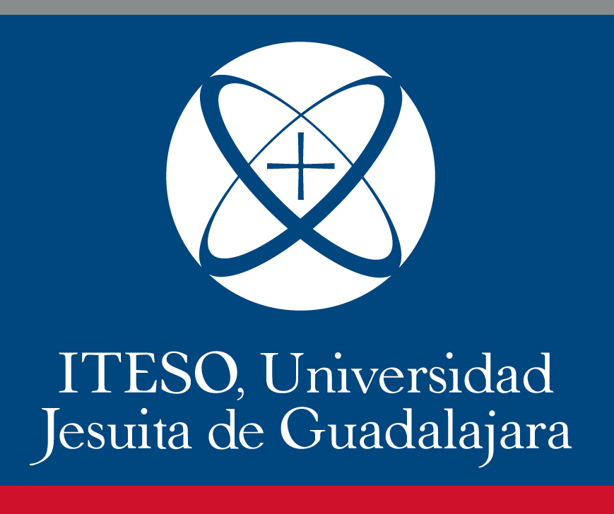
Course: Mexican Art History
Syllabus

Time and place | Fridays 09h – 11h / Online (Zoom)
Language | English
Credits | 4 (2 Under teacher guidance + 2 Independent student time)
Group | CPC3155C
Department | Departamento de Estudios Socioculturales
Academic program | Licenciatura en Gestión Cultural
Basic academic unit | Apreciación y Dominio de los Lenguajes Artísticos y Expresiones Culturales

NOTE: Fall 2022 semester will begin in August. It is important to consider that on October 30, in Mexico, we change to wintertime. This means that we set the clock back one hour. Take notice of this when you enroll this subject.

Professor: Alejandra Petersen Castiello
Email: alejandrapc@iteso.mx

Teaching coordinator: Julia A. Magaña Najera
Email: juliam@iteso.mx

- General information

Mexican Art History in the twentieth century went through dramatic changes. It started out as a dictatorship, where French manifestations in art, fashion and architecture were highly encouraged. Then came the 1910 Revolution, which brought a new configuration in the government and thus a new way of thinking about art. It was in these next years after the Revolution that art became a tool for unifying –at least conceptually- a vast and diverse land. As art in the Post Revolution period was assimilated by the government, new forms appeared as retaliation. This was particularly evident after the student movements of 1968.

- General Objective

To analyze Mexican Art History in its different phases, situating actors, movements and the institutions that contributed to its formation. The study of these factors will help develop and encourage reflections around Mexico’s spiritual and material conformation.

- Specific Objectives

- To understand the generalities of Mexican Art History in the twentieth century
- To visualize art beyond its image and into its political, social, and material meaning
- To identify areas unexplored by mainstream Art History
- To understand the complexities of artistic movements in Mexico beyond the best known muralists
- To learn about Muralism and architecture not only in Mexico City but in Jalisco as well
- To include cinematography and architecture into the class discussion
- To develop oral, reading, and writing skills in English

- Methodology

This course is organized chronologically starting at the dawn of the nineteenth century and ending with contemporary collectives and artists from the 1990s.

The class will be taught through seminars, readings, group discussions, and field trips. It is expected that students read the texts thoroughly as to engage in an active discussion. Participation must be carried out in English; essays, reading and oral reports must be written/spoken in English.

If you need help with your writing skills contact de Language Department (DEL) and ask for tutoring options.

Some activities and readings could be modified. If that is the case, students will be notified one week in advanced.

- Policies

It is ITESO’s policies that students must attend to at least to 80% of the sessions to have the right for evaluation. That means that students can only miss 3 classes. There are no justified absences. Please email the professor in advanced if you plan to miss a session.

Class begins 10 minutes after 9am. If students arrive late they can enter the classroom but an absence will be registered.

Cellphone use is not permitted during class except if requested by the professor for teaching purposes.

Essays, papers or presentations will not be received after the date marked on the activities calendar below. Each project must be coherent, structured, with correct grammar and spelling. It is mandatory to acknowledge other people’s ideas by quoting.

Reading reports requirements: 400 words, double spaced, Arial font (12 points), and quotations in APA format. Reports must contain a short summary of the reading(s) and the student’s own thoughts on the subject. Reports should be emailed to the professor.

Essay requirements: 750 words, double spaced, Arial font (12 points), and quotations in APA format. Essays must express a concise argument and must contain an introduction, body and conclusions.

Final paper requirements: 1500 words, double spaced, Arial font (12 points), and quotations in APA format. Must be an original idea within the course’s time period. It could be focused on an artist, a specific piece or an artistic movement. Additionally, the paper should express the topic’s relation with its context of creation and with our own (how does the artist/work/group resonate nowadays?). The argument should be clearly stated and convincingly developed.

In any case plagiarism will be penalized and notified to the career Coordinator.

- Evaluation
Pecha Kucha presentation: 20%
Essay on architecture: 15%
Timeline: 5%
Activities on Canvas (discussions, reading reports, oral, reports, etc. total of 10): 30%
Readings and class participation: 10%
Final essay: 20%
Total: 100%

There will be extra points assignments

Final grade will be rounded to the next highest whole number (i.e. 8.5 turns into a 9 but 8.4 turns into 8).

VIII. Contact
We will contact through email, Canvas Chat and a WhatsApp group.

IX. Learning resources

Novels based on historical facts

Fernando del Paso, News from the Empire, 1987, 2009
Kathryn S. Blair, In the Shadow of the Angel, 2011
Leonardo Padura, The Man Who Loved Dogs, 2009, 2013
Elena Poniatowska, Leonora, 2011, 2015
Elena Poniatowska, Tinisima, 1992, 2006

Bibliography

Bixler E. Jaqueline. "Mexico 1968 and the Art(s) of Memory" in Daniel J. Sherman (ed.). The Long 1968: Revisions and New Perspectives. Indianapolis: Indiana University Press, 2013.

Coffey K. Mary. How a Revolutionary Art Became Official Culture: Murals, Museums and the Mexican State, Durham: Duke University.

Comisarenco, Dina, "To Paint the Unspeakable: Mexican Female Artist's Iconography of the 1930s and Early 1940s" in Women's Art Journal, vol. 29, no. 1, Spring 2018, pp. 21-32.

Cordero, Karen. "The Best Maugard Drawing Method" in The Journal for Decorative and Propaganda Arts, Florida: International University, 2010.

Debroise Oliver and Cuauhtémoc Medina (eds.), La era de la discrepancia: arte y cultura visual en México, Mexico City: UNAM, 2007, 2014.

Klich, Lynda. "Estridentópolis: achieving a post-revolutionary utopia in Jalapa" in The Journal for Decorative and Propaganda Arts, Florida: International University, 2010.

López, Rick. A. Crafting Mexico: Intellectuals, Artisans and the State after the Revolution. Durham: Duke University Press, 2010.

Martínez Rodríguez, Fabiola. "Representing the nation: art and identity in Porfirian Mexico" in National Identities, vol. 15, no. 4, pp. 333-355.

O`Rourke, Kathryn E. Modern Architecture in Mexico City: History, Representation, and the Shaping of a Capital, Pittsburgh, University of Pittsburgh, 2016.

Ramírez Berg, Charles. The Classical Mexican Cinema: The Poetics of the Exceptional Golden Age Films, Austin: University of Texas, 2000.

Stavans, Ian. José Vasconcelos: The Prophet of Race. New Brunswick: Rutgers, 2011.

Films

Sergei Eisenstein (dir.) Qué Viva México! 1932, 1979
Teresa Griffiths (dir.) Leonora Carrington: The Lost Surrealist, 2017
Luis Buñuel (dir.) Los Olvidados,1950

*This is not a definitive list and more resources will be added throughout the semester

